Computer Language Coding Concepts

System Objects Summary in a Diagram
The article System Objects Summary already gave a summary of the system objects articles. The current article further explains it with diagrams.

Below you will find a diagram, that displays the usage of some of the terms summarized in the article System Interface Summary.

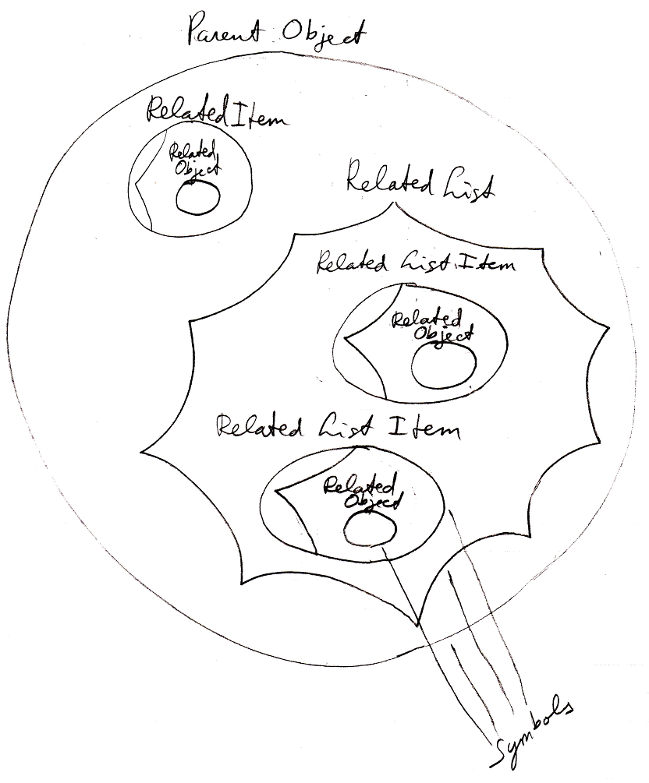

The diagram displays a Parent Object, containing a Related Item and a Related List. The Related Item contains a Related Object, which is the pointer to the target of the Related Item. The Related List contains two Related List Items, each of which contains a Related Object, that is the pointer to the target of the Related List Item. It is denoted that all graphical shapes in the diagram are symbols, and the term symbol is no synonym for either one of the other terms; it is just a shape displayed on screen.

The diagram below displays the complete system interface of a related item:

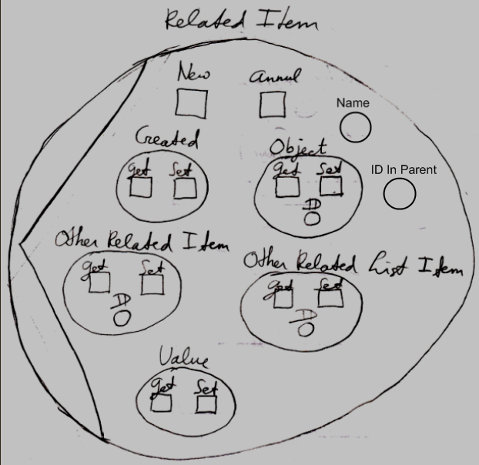

It shows all the system interface members, except for the new ones that will be added by other concepts. So only the most basic system object members were covered.

The diagram below displays the same system object members for a related list item. The related list item has the same system members as a related item, except for the three additional members List, ID in List and Remove.

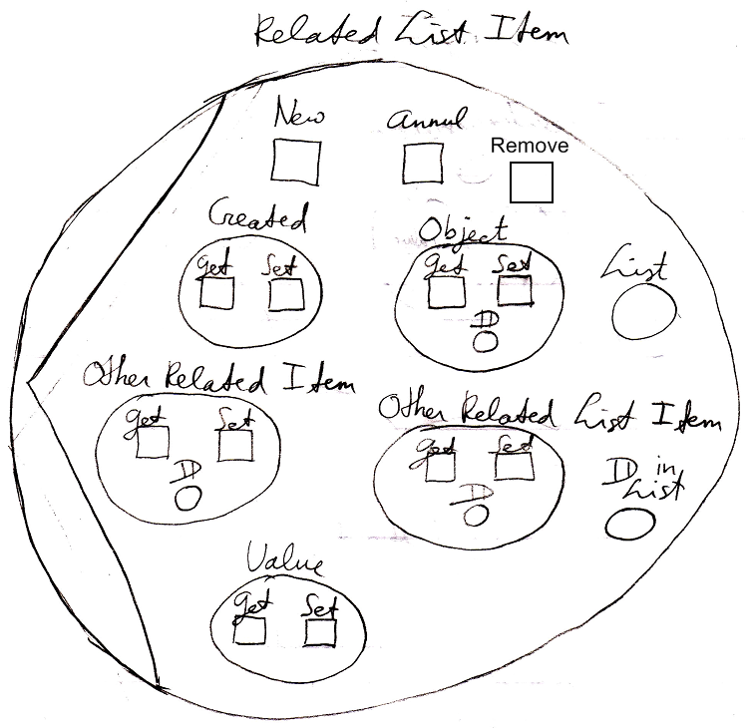

Futhermore, there is the system interface of a related list, which only contains the Add command, but defines an object containing the extension procedures for related list items:

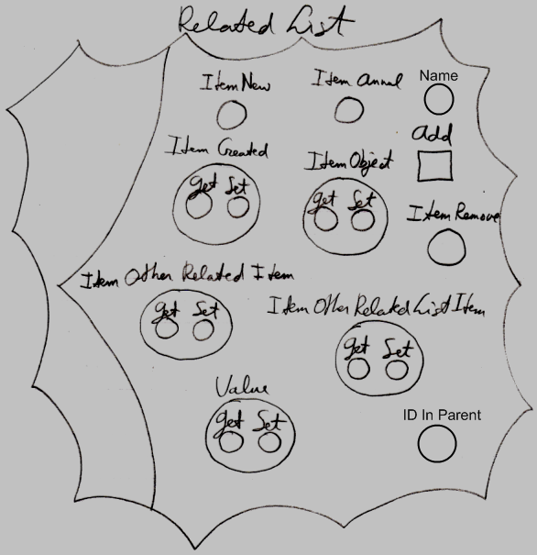

An object itself also has a system interface, consisting of two collections: Related Items and Related Lists.

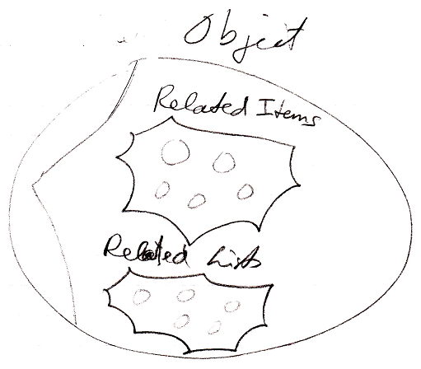

But an object itself is never shown in the diagram. You are always seeing related items or related list items, never the objects themselves. It is not clear yet how the Related Items and Related Lists collections will be show in the diagram. See the article Related Items & Related Lists Collections in a Diagram.

Concepts, introduced in the future, may add more members to the system interface of related items, related lists, related list items and objects.

Usually not all members of a system object are shown, but only the parts that are extended or used. In that case the diagram shows an ellipsis in the spots where the additional members are not displayed:

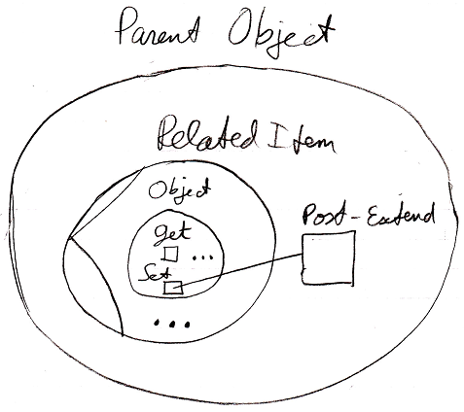

Each ellipsis can be double cliked or clicked, or something, to show all the other system object members and extension possiblities.
When you double click the ellipsis inside the Object part of the system interface, all the Object members are shown and their extension possibilities:

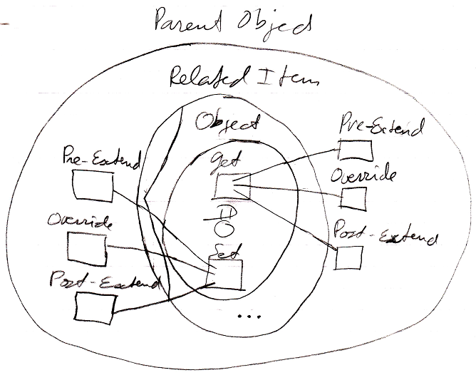

If you double click the ellipsis at the bottom of the related item symbol, all system interface members are shown, but not their members.

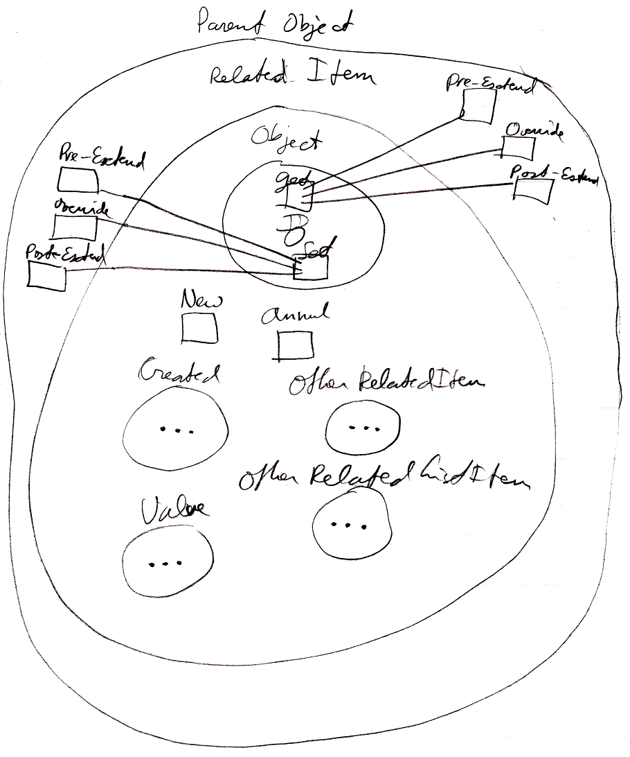

To also display the members and extension possibilities of another part of the system interface, you have to double-click another ellipsis.

See also: System Objects, System Objects Summary

Author & Copyright: Jan-Joost van Zon Date: July 20, 2008 – July 24, 2008 Location: Oosterhout, The Netherlands Status: Finished

